

**DEPARTMENT OF COMPUTER SCIENCE**

**AND APPLICATIONS**

**IBM PROJECT REPORT**

Real-Time Call Center Optimization with Call Sense

*Submitted by*

*K.Santhosh*

*S.Vishwanath*

*R.Gayathri*

**BACHELOR OF SCIENCE IN COMPUTER**

**SCIENCE WITH ARTIFICIAL INTELLIGENCE**

*Under the guidance of*

*ANUPAMA .K- Corporate Trainer*

**2023 - 2024**

**DECLARATION**

We, **Santhosh .K, Vishwanath .S and Gayathri .R . A** hereby declare that this project report on **“**Call center data using COGNOS tool” submitted to University of Madras in partial fulfilment of the requirement for the award of the Degree Bachelor of computer science with Artificial Intelligence under the guidance of **DR.G.MONIKA M.Sc., PhD., HEAD OF DEPARTMENT** and ANUPAMA.K has not been submitted earlier to any other university or institute for the award of any degree.

**Santhosh.K**

**Vishwanath.S**

**Gayathri.R**

**Place:**

**Date:**

**BONAFIDE CERTIFICATE**

This is to certify that the project titled “Real-Time Call Center optimization with call sence data using COGNOS tool”is the bonafide work done by

**Santhosh.K,Vishwanath,S and Gayathri.R** hereby and first year student of Jeppiaar College of Arts and Science , Padur, Chennai in partial fulfilment of the requirment for the award of the Degree of Bachelor of computer Science with Artificial Intelligence 2023-2024.

**PROJECT GUIDE:** ANUPAMA.K

**HEAD OF THE DEPARTMENT:**

**Date:**

|  |  |  |
| --- | --- | --- |
| **S. No** | **INDEX** | **Page No** |
| 1. | INTRODUCTION |  |
| 2. | ABSTRACT |  |
| 3. | REPORTS |  |
| 4. | FINAL DASH BOARD |  |
| 5. | CONCLUTION |  |
| 6. | REFERENCE |  |

**INTRODUCTION:**

Our project focuses on leveraging IBM COGNOS Analytics for analyzing Real-Time Call Center optimization with call sence data. With COGNOS' versatile toolbox including List, Text Item, Block, Table, Crosstab, and Visualization features, we delve into data exploration and analysis. By uncovering trends and patterns, we aim to enhance operational efficiency and elevate the guest experience in the hospitality industry. Join us as we utilize COGNOS to extract actionable insights and drive informed

Top of Form

Top of Form

**ABSTRACT:**

This project explores the utilization of IBM COGNOS Analytics for analysis the Real-Time Call Center optimization with call sence data, aiming to enhance to easily understanding .Leveraging COGNOS' versatile toolbox, including List, Text Item, Block, Table, Crosstab, and Visualization features, we delve into data exploration and analysis. Join us on this journey as we showcase the power of COGNOS in unlocking the potential for strategic decision-making and operational excellence in hotel management.

**REPORTS:**

Top of Form

1. **CALL CENTER AS LIST:**

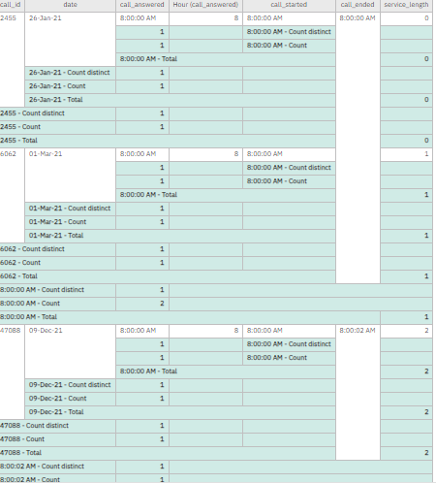

1. **NO.OF. SEVICE LENGTH:**

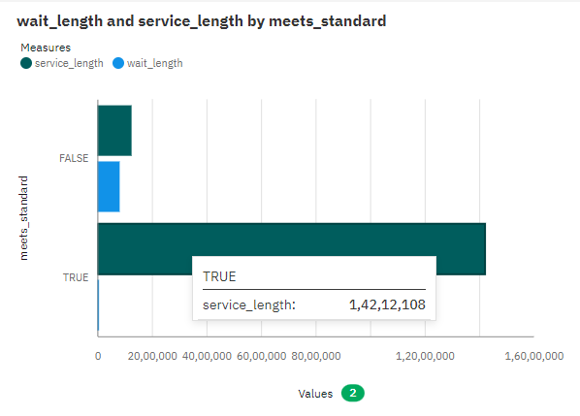

1. **NO. OF. DAILY CALLER TRUE WAIT LENGHT*:***

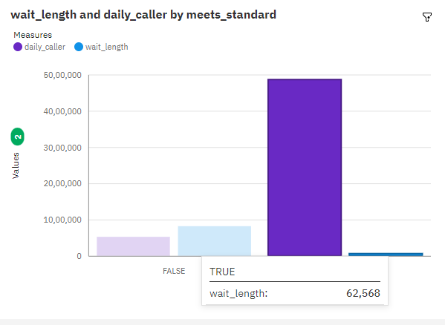

1. **NO. OF. DAILY CALLER :**

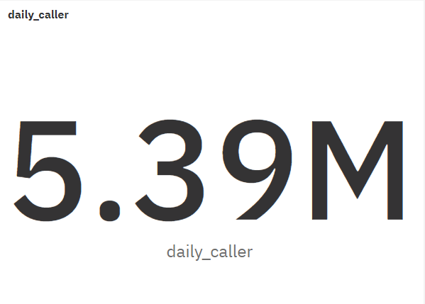

**FINAL DASH BOARD OF HOTEL MANAGEMENT:**

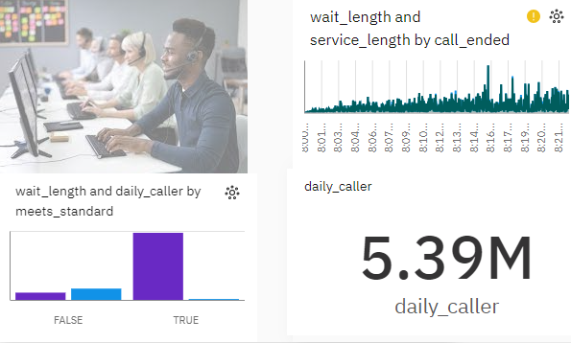

**CONCLUTION:**

Our project has used IBM COGNOS Analytics to study the call centre. We've explored different parts of the data using tools like lists, tables, and visualizations. By doing this, we've found trends and patterns that help to analysis and easily to understand.

Our work is just the beginning. We'll keep using COGNOS Analytics to find even more ways to improve how to better understanding the call centre.

**REFERENCE**:

<https://www.kaggle.com/datasets/donovanbangs/call-centre-queue-simulation/data><<iframe src="https://sa1.ca.analytics.ibm.com/bi/?perspective=dashboard&amp;pathRef=.my_folders%2FSVG&amp;closeWindowOnLastView=true&amp;ui_appbar=false&amp;ui_navbar=false&amp;shareMode=embedded&amp;action=view&amp;mode=dashboard&amp;subView=model0000018f0f166af2_00000000" width="350" height="200" frameborder="0" gesture="media" allow="encrypted-media" allowfullscreen=""></iframe>>